Top 10 Considerations for data from an EC:

**1. Property Address** -  Should match what is on the application.  Additional insights:  '123 Main Street' and '123 Main St' would be considered a match.  City names may vary, but can be resolved by reviewing zip code lookup on [USPS](https://tools.usps.com/zip-code-lookup.htm?citybyzipcode)website.

**2. Diagram Number** - When present, this should match what is on the application.

**3. Total enclosure size and flood vents** - For Diagrams 6-9 only.  The square footage of the crawlspace/enclosure (A8a) and the garage (A9a), should align with the total enclosure size on the application.  Similarly, the number and size of the vents should align with the application (Created Rule #11 for the vents).

**4. CBRS / OPA** - If the EC indicates the property is in a CBRS/OPA, underwriting must obtain construction/community documentation verifying the building's eligibility.

**5. Building Elevations are Based On** - An EC that is completed based on Construction Drawings or a Building Under Construction is only valid for use with an application that describes the building as under construction.  A Finished Construction EC is required when the policy is insuring a building that is not under construction.

**6. Signature** - When Section C measurements are used, Section D must include the surveyor's name, license #, and have a signature.  When Section E measurements are used, Section F must be completed and include the representative's name and signature.   When Section H measurements are used, Section I must be completed and include the representative's name and signature.

**7. Elevation Logic (Section C) - Only applicable when the application is using Section C measurements**

1. When the application shows that Section C elevations are used, the elevations on the application should match the EC.
2. **C2a:**  For building diagrams 1, 1a, 3, 6, 7, and 8.  The top of bottom floor elevation should be within 2 feet of the LAG, but not below the LAG.   For building diagram 1b, the elevation should be within 6 feet of the LAG, but not below the LAG.  For building diagrams 2, 2a, 2b, 4, and 9, the elevation should be below the LAG.  For diagram number 5, the elevation should be within 20 feet of the LAG, but not below the LAG.
3. **C2b**: For diagrams 2, 4, 6, 7, 8, and 9.  The top of next higher floor should be present, and the elevation should be greater than the top of bottom floor (C2a). If C2b is >20 feet above C2a, then refer to underwriting.
4. The LAG (**C2f**) should be a lower elevation than the HAG (**C2g**).
5. If the elevation difference between either the top of bottom floor (C2a) or the top of next higher floor (C2b), in comparison to the Lowest Adjacent Grade (C2f) is >20 feet, these should require an underwriting review as such a scenario is extremely rare.

**8. Elevation Logic (Section E) - Only applicable when the application is using Section E measurements**

1. When the application shows that Section E elevations are used, the elevations on the application should match the EC.
2. **E1b**:  For building diagrams 1, 1a, 3, 6, 7, and 8.  The elevation should be within 2 feet of the LAG, but not below the LAG.   For building diagram 1b, the elevation should be within 6 feet of the LAG, but not below the LAG.  For building diagrams 2, 2a, 2b, 4, and 9, the elevation should be below the LAG.  For diagram number 5, the elevation should be within 20 feet of the LAG, but not below the LAG.
3. **E2**.  The elevation should be present for building diagrams 6, 7, 8, and 9.  The elevation should be a higher value when compared to E1a.
4. If E1a, E1b, or E2 is >20, these should require an underwriting review as such a scenario is extremely rare.

**9. Elevation Logic (Section H) - Only applicable when the application is using Section H measurements**

1. When the application shows that Section H elevations are used, the elevations on the application should match the EC.
2. **H1a:** For building diagrams 1, 1a, 3, 6, 7, and 8.  The top of bottom floor elevation should be within 2 feet of the LAG, but not below the LAG.   For building diagram 1b, the top of bottom floor should be within 6 feet of the LAG, but not below the LAG.  For building diagrams 2, 2a, 2b, 4, and 9, the top of bottom floor should be below the LAG.  For diagram number 5, the top of bottom floor should be within 20 feet of the LAG, but not below the LAG.
3. **H1b:**  For diagrams 2, 2a, 2b, 4, 6, 7, 8, and 9.  The top of next higher floor should be present, and the elevation should be greater than the top of bottom floor.
4. If H1a or H1b is >20, these should require an underwriting review as such a scenario is extremely rare.

**10. Machinery and Equipment Logic - Only applicable if the application indicates the machinery and equipment is elevated above the first floor:**

1. For diagrams 1, 1a, 1b, and 3
   1. Section C: C2e should be equal or greater than C2b.  If C2b is not present, then it must be at least 8 feet higher than C2a.
   2. Section E:  E4 should be at least 8 feet higher than E1b.
   3. Section H:  H2 should be marked 'Yes'
2. For diagram 2, 2a, 2b, 4, 6, 7, 8 and 9
   1. Section C:  C2e should be equal to or greater than C2b.
   2. Section E:  E4 should be equal to or greater than E2.
   3. Section H:  H2 should be marked 'Yes'
3. For diagram 5:
   1. Section C:  C2e should be equal or greater than C2a.
   2. Section E:  E4 should be equal to or greater than E1b.
   3. Section H:  H2 should be marked 'Yes'

**The following replaces Rule #10 effective 10/1/2025. These updates are the result of FEMA Bulletin W-25003 and new Flood Insurance Manual effective 10/1/2025. Also see updates to Rule #24.**

1. If the property is in a SFHA and there is a current BFE, then the C2e elevation should be at or above the current BFE. **Note**: The BFE must be pulled from the current flood insurance rate map (FIRM). Since ECs don’t expire, the FIRM referenced on the EC may be an old map. The flood zone determination can be used to determine the current FIRM.

If the C2e elevation is less than the BFE, or if a BFE is not present, or the property is in a non-SFHA, then continue to Steps 2-4.

1. For diagrams 1, 1a, 1b, and 3
2. Section C: C2e should be within a foot of C2b or greater than C2b.  If C2b is not present, then it must be at least 8 feet higher than C2a.

ii. Section E:  E4 should be within a foot of E2 or greater than E2. If E2 is blank, then E4 should be at least 8 feet higher than E1b.

iii. Section H:  H2 should be marked 'Yes'

3. For diagram 2, 2a, 2b, 4, 6, 7, 8 and 9

i. Section C:  C2e should be within a foot of C2b or greater than C2b.

ii. Section E:  E4 should be within a foot of E2 or greater than E2. If E2 is blank, then E4 should be at least 8 feet higher than E1b.

iii. Section H:  H2 should be marked 'Yes'

4. For diagram 5:

i. Section C:  C2e should be within a foot of C2b or greater than C2a.

ii. Section E:  E4 should be within a foot of E1b or greater than E1b.

iii. Section H:  H2 should be marked 'Yes'

**Rule #11:** For Diagrams 6, 7, 8, and 9 the total number and size of the vents on the EC (Sections A8 + A9), should match what is on the application. (See 2025-3-11 Answer for Umer document for further details on this rule.)

**Photograph Rules**

Rule #12 - Photographs are not required when an application is insuring a building under construction. However, if photographs are provided, these should be evaluated to ensure alignment with the EC.

Rule #13 - The photographs must show an eligible building, which is a building that is affixed to a permanent site, and has two or more outside rigid walls with a fully secured roof. If the photographs do not show a building, underwriting review is required.

Rule #14 - The photographs of the building should align with the occupancy type selected on the application: Single-family Home, Residential Manufactured/Mobile Home, Residential Unit, Two-to-four Family Building, Other Residential Building, Residential Condominium Building, Non-residential Building, Non-residential Manufactured/Mobile Building, Non-residential Unit.

**Note:**  If it is a residential / non-residential unit, two-four family, Other Residential, or residential condominium building, we would expect to see a multi-unit structure.

Rule #15 – A building that is entirely over water is not eligible for coverage. Instances in which the photographs show this as a possibility should be referred to Underwriting.

Rule #16 - The photographs must show, at a minimum, the front and back of the building, including the foundation system and the number of floors.

Rule #17 – The photographs should confirm the Foundation Type of a Building. This also correlates with the Diagram Number (1, 1A, 1B, 3 = Slab on Grade. 2, 2A, 2B, 4 = Basement. 5 = Elevated Without Enclosure on Posts/Piles/Piers. 6 = Elevated With Enclosure on Posts/Piles/Piers. 7 = Elevated With Enclosure Not On Posts/Piles/Piers. 8, 9 = Crawlspace)

* Note: Special attention should be paid to applications that indicate a Diagram 5. Oftentimes, an owner will subsequently enclose the area beneath, resulting in a Diagram 6.

Rule #18 – The photographs should confirm the number of floors stated on the application. Note that when determining the number of floors for a building, do not count mid-level entries, enclosures, basements, or crawlspaces (on grade or subgrade) as a floor.

Rule #19 - The presence of dormers may be decorative or indicate the presence of an additional floor. Underwriting review should be required.

Rule #20 - The photographs should be used to verify the Construction Type (frame, masonry, other). If the application specifies “Other”, then accept as presented. If it states Frame, flag for underwriting if brick or masonry walls are present. If it states Masonry, then anything other than brick or masonry walls should be flagged.

Rule #21 - If the photographs show there are additions or extensions, then closer evaluation is needed to ensure the measurements within the EC have accounted for those additions/extensions. An addition/extension may be a separate structure connected to the building by means of an elevated platform or roof.

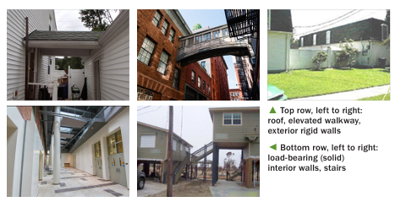

Note in the lower right photo we see two buildings connected by stairs. If the measurements on the EC only take into consideration the building on the right, then we would need to obtain an updated EC so that the left building is taken into consideration. Without it, we could be rating the home as having a 1st floor that is 10 feet off the ground (right building), when at the time of loss, both buildings are covered, and the rating should have reflected a home whose lowest floor is 6 feet off the ground (left building)

Rule #22 – Areas below the elevated floor that are constructed with open lattice and slats are not considered an enclosure. The building would still be considered a Diagram 5.

Rule #23 - If the building is a Diagram 5, and there is evidence of an enclosed elevator shaft, the building would be considered a Diagram 6.

Rule #24 - If the application indicates the machinery and equipment (M&E) is elevated above the first floor, then the photographs should not show any exterior M&E below the applicable level. Examples of exterior M&E include: A/C Condenser, Elevator, Generator, and Solar Battery Elements. The illustration below shows the level to which the M&E would need to be elevated to.

Updated guidance effective 10/1/2025:

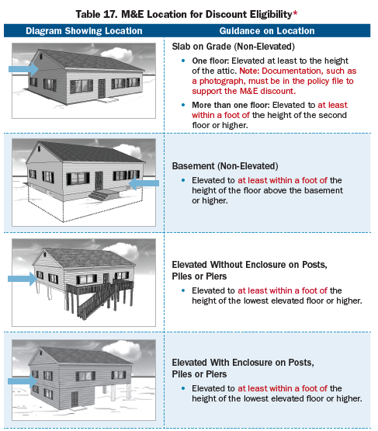

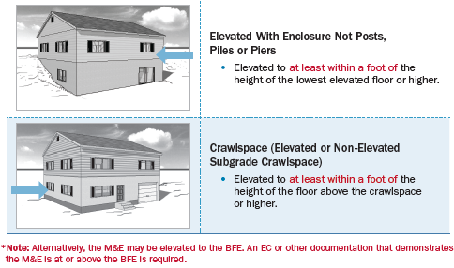

**Additional items to consider**

* Diagram 1, 1a, and 1b are all considered slab on grades. A diagram 1B is specifically used to describe a stem-wall foundation system (or a very thick slab).
* Diagram 2, 2a, and 2b are all considered buildings with a basement. A diagram 2b is a basement building with an exterior egress.
* When an EC and/or App shows Diagram 8:
  + If there is more than a 5 foot difference between the top of bottom floor and the top of the next higher floor, it would no longer be considered a Diagram 8. We would rate it as a Diagram 7.
* When an EC and/or App shows Diagram 9:
  + If the top of bottom floor is more than 2 feet below the LAG, it is no longer considered a Diagram 9. The building would be considered as having a basement and the application should be amended to a Diagram 2 and the basement foundation selected.
  + If the difference between the top of bottom floor and the top of next higher floor is more than 5 feet, it is no longer considered a Diagram 9. The building would be considered as having a basement and the application should be amended to a Diagram 2 and the basement foundation selected.
* If the flood zone on the EC and the Zone Determination reference **the same** flood insurance rate map (FIRM), but have a different zone, then the application should show the more hazardous zone unless other zone documents are available. Flood zones in order from most to least hazardous: VE,V1-V30, V, AE, A1-A30, A, AH, AO, AR, D, X, B, C
* If the flood zone on the EC and the Zone Determination reference **a different** flood insurance rate map (FIRM), then the FIRM information and zone from the more recent FIRM should be reflected on the application.

Rule #XXXXX - Although the EC form has an expiration date, the usage of that form never expires. If the EC was completed on a valid form at the time of completion, then it can be used for rating regardless of the form’s expiration date. Shown below is the table to determine if the EC was completed within a valid period of time. Please note that when a new EC form is published, there is oftentimes overlapping period in which the ‘old’ and ‘new’ form can be completed and deemed valid.

|  |  |
| --- | --- |
| **Published “Expired” Date** | **EC valid if signed on or between** |
| June 1984 | 9/30/2000 or earlier |
| February 1987 | 9/30/2000 or earlier |
| June 1990 | 9/30/2000 or earlier |
| May 1993 | 9/30/2000 or earlier |
| May 1996 | 9/30/2000 or earlier |
| July 1999 | 9/30/2000 or earlier |
| July 2002 | 8/1/1999 – 12/31/2006 |
| December 2005 | 1/1/2003 – 12/31/2009 |
| February 2009 | 2/1/2006 – 3/31/2010 |
| 3/31/2012 | 4/1/2009 – 7/31/2013 |
| 7/31/2015 | 8/1/2012 – 12/31/2016 |
| 11/30/2018 | 1/1/2017 – 2/21/2020 |
| 11/30/2022 | 2/1/2020 – 6/29/2023 |
| 6/30/2026 | 6/1/2023 - Present |

* As an example, if the EC that was completed on 10/12/2012 is on a form that expires on 7/31/2015, then the EC is acceptable. If however, when the EC that was completed on 10/12/2012 was completed on a form that expired in February 2009, then it is not valid as it wasn’t completed on the proper form at the time of completion.
* Surveys that are done prior to 10/1/2000 can be on any EC form. However, these should be referred to Underwriting.
* EC’s that have an Expiry date prior to 2002 are in a different format, and there is not a “Top of Bottom Floor” and “Top of Next Higher Floor”. Rather, there is a “Reference Level Floor” election. For Diagrams 1-4, the reference level is the building’s lowest floor. For Diagrams 5-8, the reference level is the first elevated floor. An underwriter may need to derive missing elevations.
* If, during the review of the EC or photographs, a correction to the application is needed, then the premium must be recalculated after the application is updated to ensure the proper premium is calculated. This may result in a higher premium, and require the application to be approved with reduced limits based on what the premium on file will support.